Batch: C3 Roll No.: 16010123217

Experiment No. 01

Grade: AA / AB / BB / BC / CC / CD /DD

Signature of the Staff In-charge with date

TITLE: Exploring basic Commands of UNIX: Shell, Processes, Files
_____________________________________________________________________

AIM: To Explore basic commands for handling File system under Unix/Linux using shell scripts.(Creating groups, chown , chmod , directory name, tty , diff, umask).
______________________________________________________________________
Expected Outcome of Experiment:

CO 1. To introduce basic concepts and functions of operating systems.
_____________________________________________________________________
Books/ Journals/ Websites referred:

- Silberschatz A., Galvin P., Gagne G. “Operating Systems Principles”, Willey Eight edition.
- Achyut S. Godbole , Atul Kahate “Operating Systems”, McGraw Hill Third Edition.
- Sumitabha Das “ UNIX Concepts & Applications”, McGraw Hill Second
Edition.
_____________________________________________________________________
Pre Lab/ Prior Concepts:

An operating system (OS) is a resource manager. It takes the form of a set of software routines that allow users and application programs to access system resources (e.g. the CPU, memory, disks, modems, printers network cards etc.) in safe efficient and abstract way.
- The operating system kernel is in direct control of the underlying hardware. The kernel provides low-level device, memory and processor management functions (e.g. dealing with interrupts from hardware devices, sharing the processor among multiple programs, allocating memory for programs etc.)
- Basic hardware-independent kernel services are exposed to higher-level programs through a library of system calls (e.g. services to create a file, begin execution of a program, or open a logical network connection to another computer).
- Application programs (e.g. word processors, spreadsheets) and system utility programs (simple but useful application programs that come with the operating system, e.g. programs which find text inside a group of files) make use of system calls. Applications and system utilities are launched using a shell (a textual command line interface) or a graphical user interface that provides direct user interaction.
Operating systems can be distinguished from one another by the system calls, system utilities and user interface they provide, as well as by the resource scheduling policies implemented by the kernel.
UNIX has been a popular OS for more than two decades because of its multi-user, multi-tasking environment, stability, portability and powerful networking capabilities.
Linux is a free open source UNIX OS for PCs.
Linux has all of the components of a typical OS :
- Kernel
The Linux kernel includes device driver support for a large number of PC hardware devices (graphics cards, network cards, hard disks etc.), advanced processor and memory management features, and support for many different types of file systems. In terms of the services that it provides to application programs and system utilities, the kernel implements most BSD and SYSV system calls, as well as the system calls described in the POSIX.1 specification.
The kernel (in raw binary form that is loaded directly into memory at system startup time) is typically found in the file /boot/vmlinuz, while the source files can usually be found in /usr/src/linux.
- Shells and GUIs
Linux supports two forms of command input: through textual command line shells similar to those found on most UNIX systems (e.g. sh - the Bourne shell, bash - the Bourne again shell and csh - the C shell) and through graphical interfaces (GUIs) such as the KDE and GNOME window managers.
- System Utilities
Virtually every system utility that you would expect to find on standard implementations of UNIX has been ported to Linux. This includes commands such as ls, cp, grep, awk, sed, bc, wc, more, and so on. These system utilities are designed to be powerful tools that do a single task extremely well (e.g. grep finds text inside files while wc counts the number of words, lines and bytes inside a file). Users can often solve problems by interconnecting these tools instead of writing a large monolithic application program.
- Application programs
Linux distributions typically come with several useful application programs as standard. Examples include the emacseditor, xv (an image viewer), gcc (a C compiler), g++ (a C++ compiler), xfig (a drawing package), latex (a powerful typesetting language) and soffice (StarOffice, which is an MS-Office style clone that can read and write Word, Excel and PowerPoint files).
______________________________________________________________________
Description of Unix Commands and options:

A. Basic and Important UNIX (Linux/macOS) Commands

1. Directory and File Management

2. Viewing and Editing Files

3. Searching and Permissions

B. Process and System Management

1. Process Control

2. System Information

C. Advanced and Useful UNIX Commands

1. Administrative and Remote Operations

2. Searching and Processing Files

3. System Monitoring and Disk Management

Screen Shot of Implemented Commands:
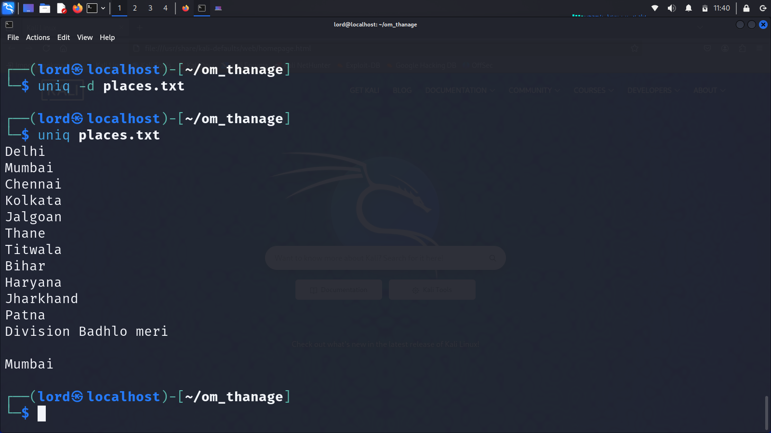
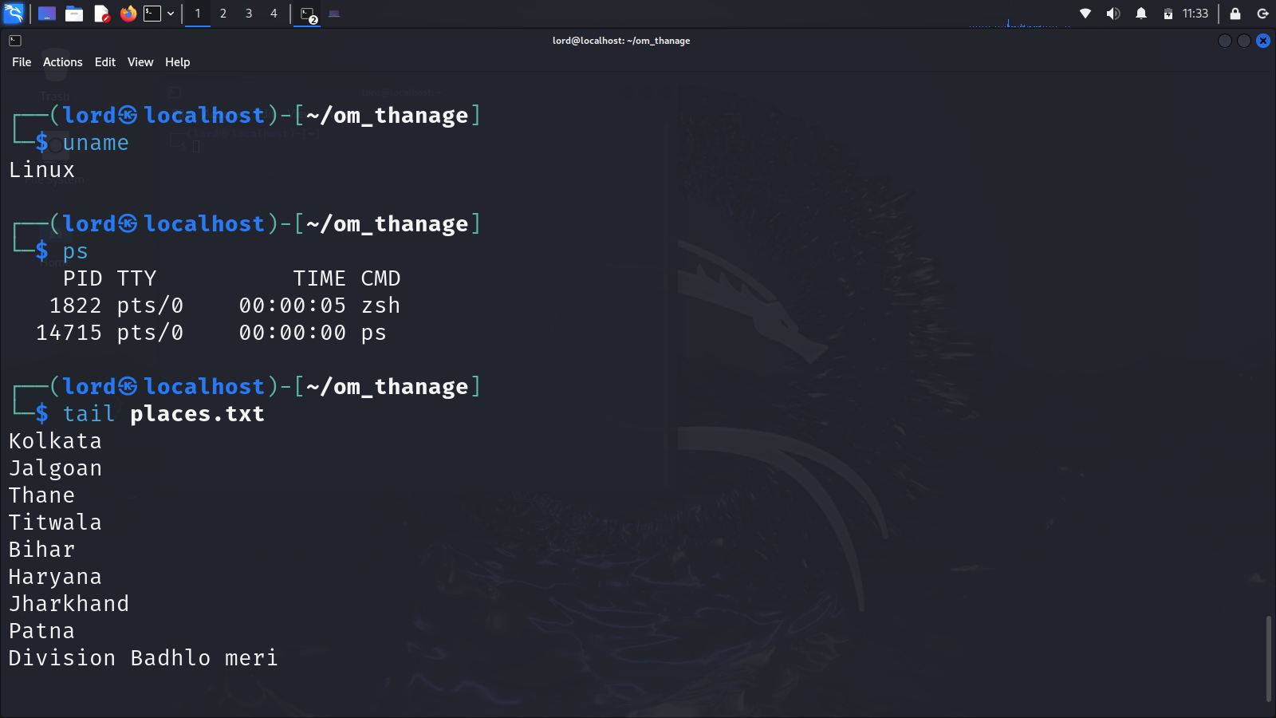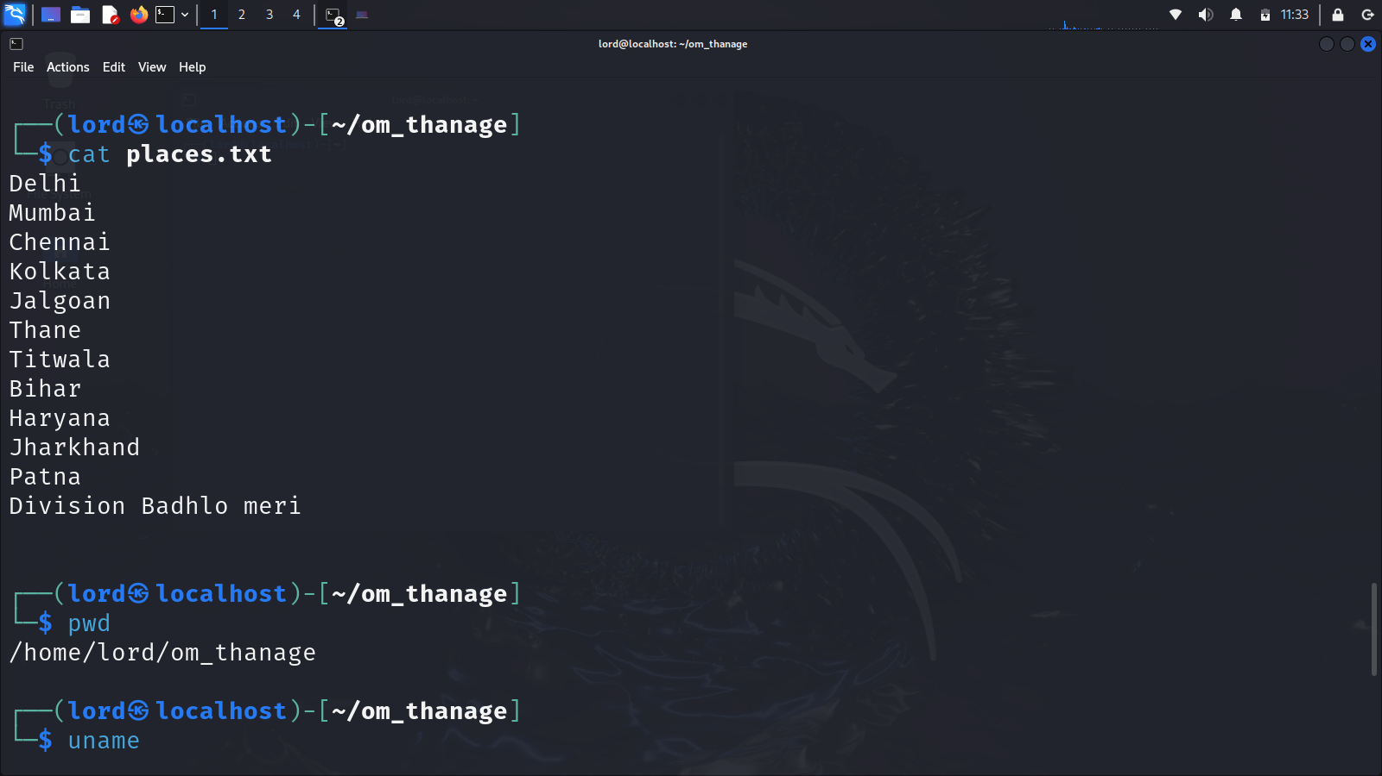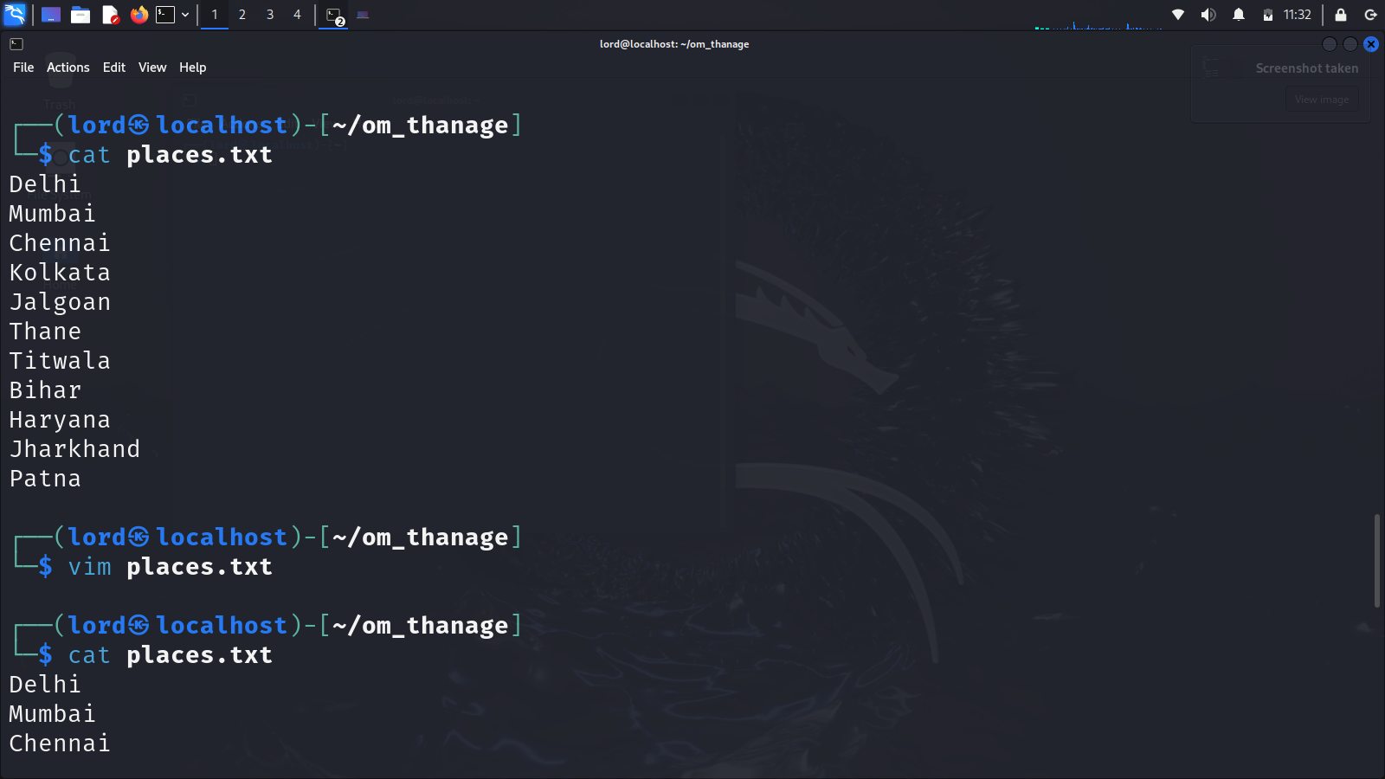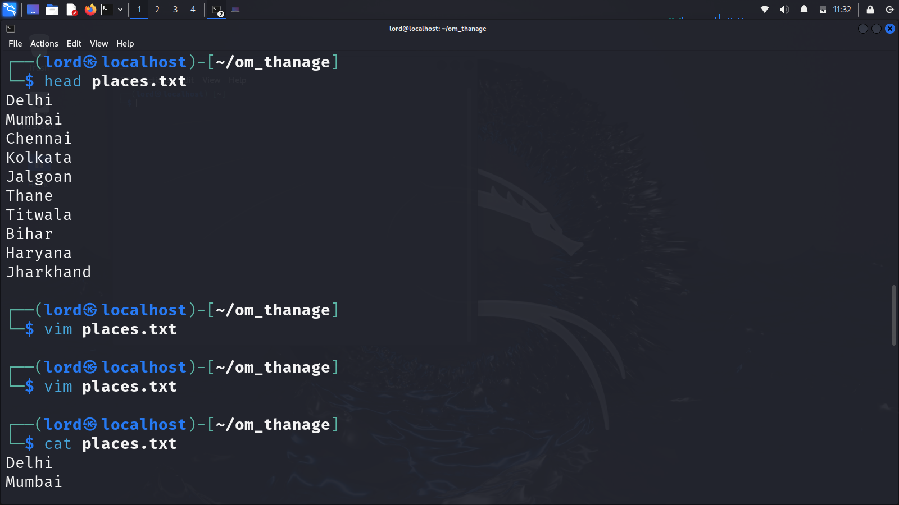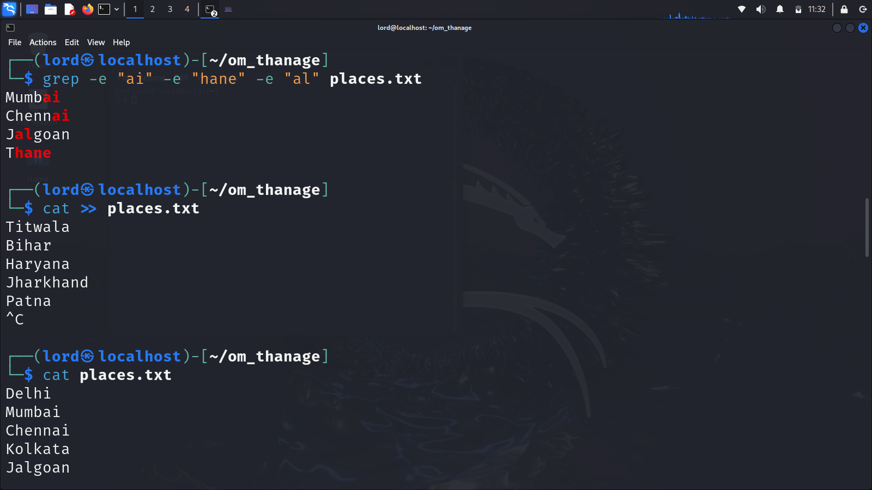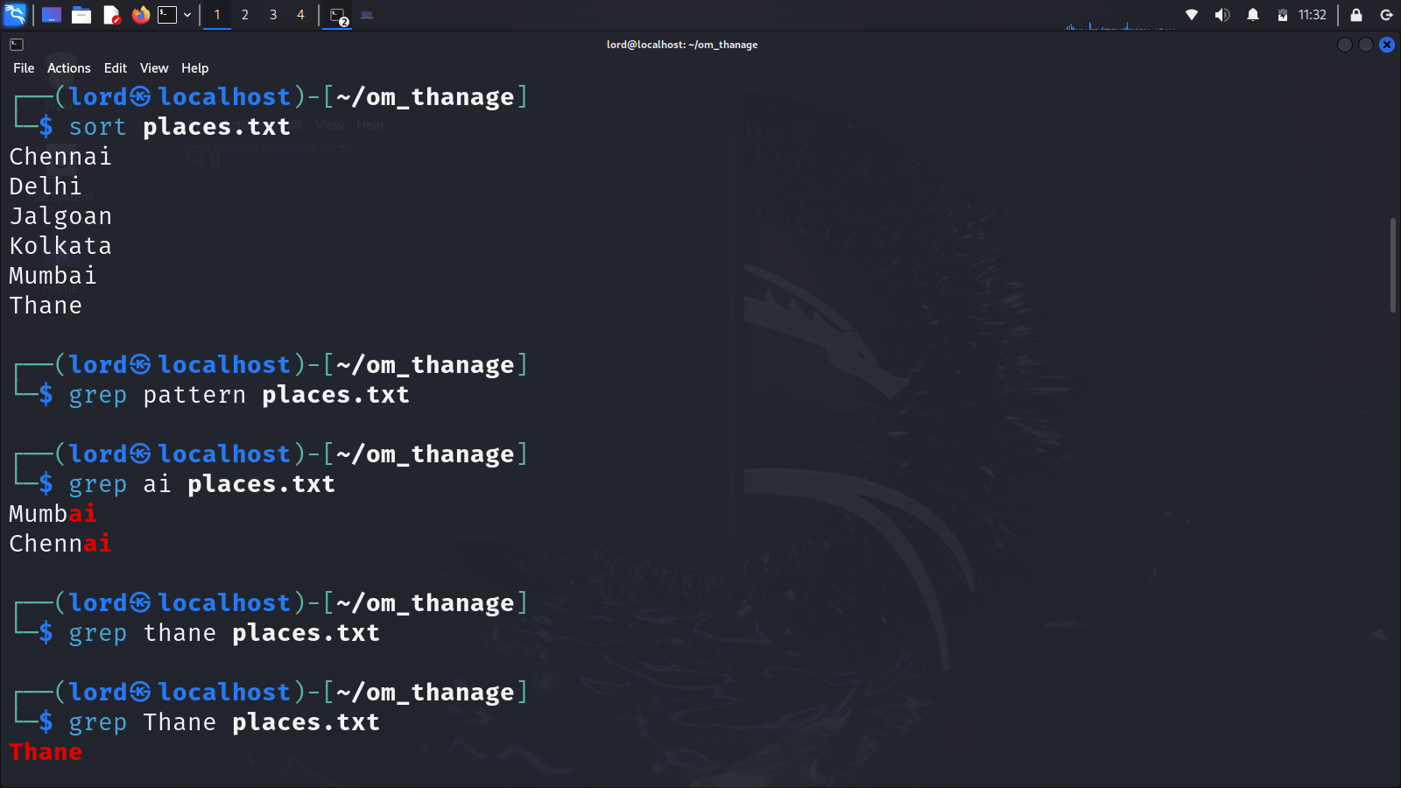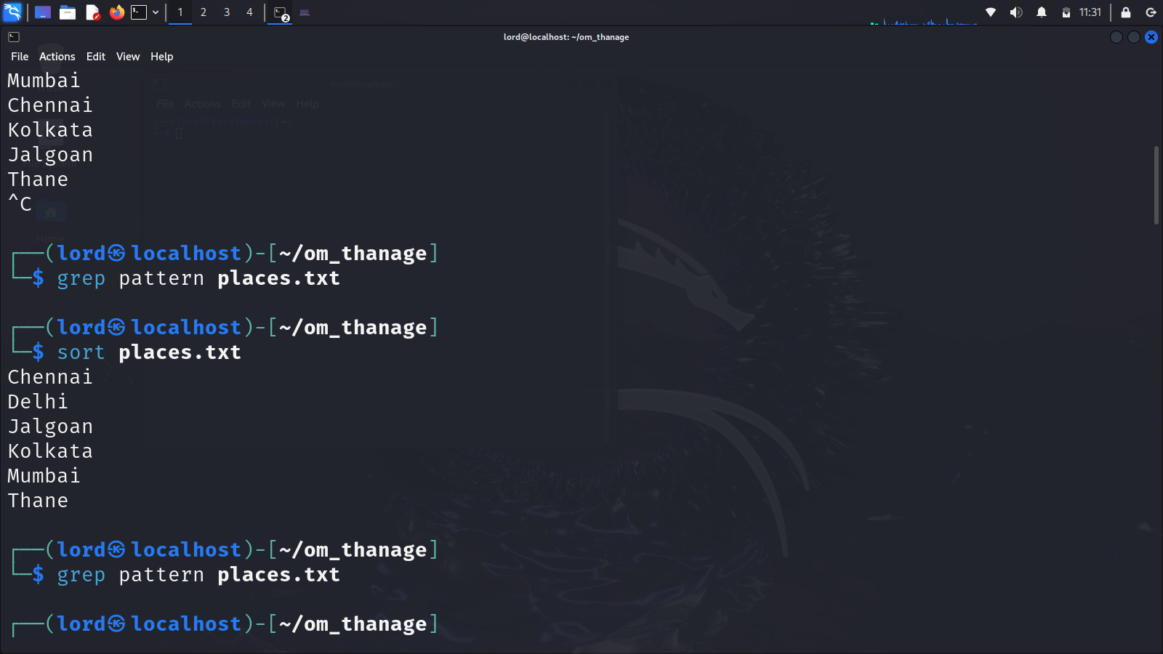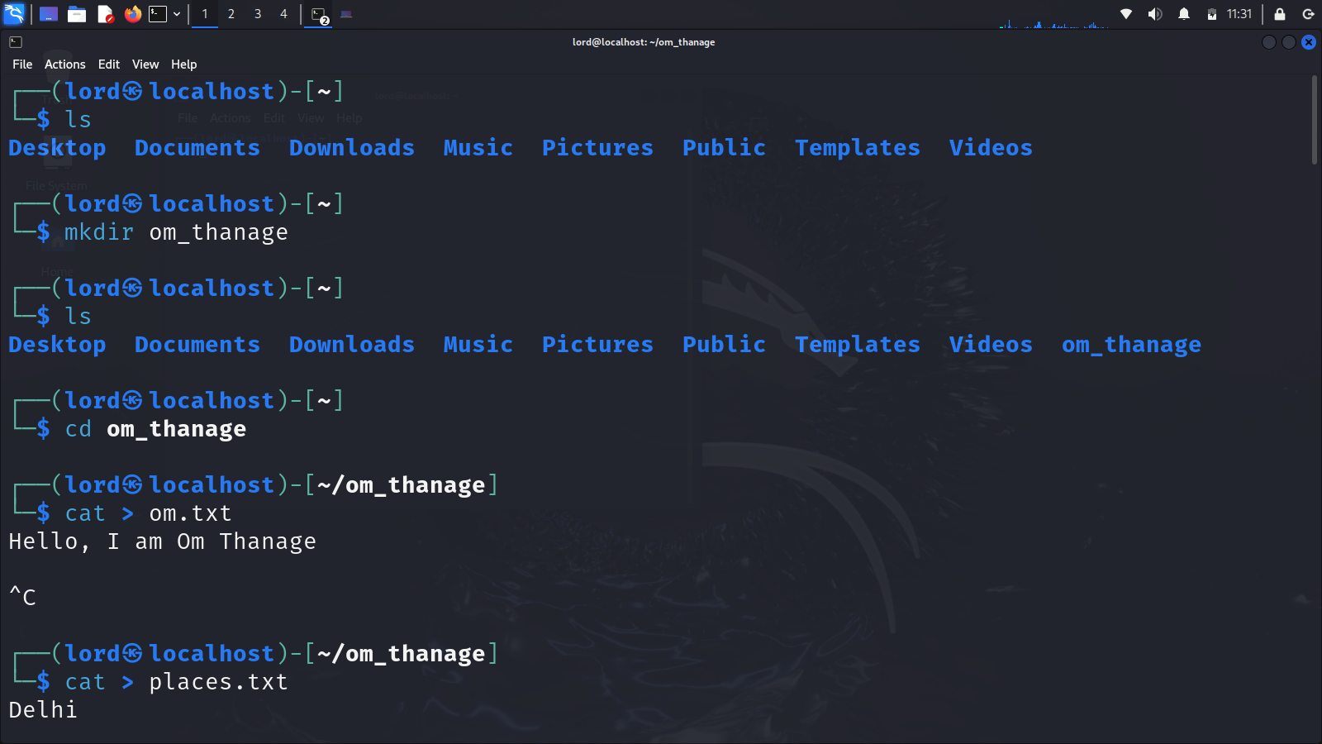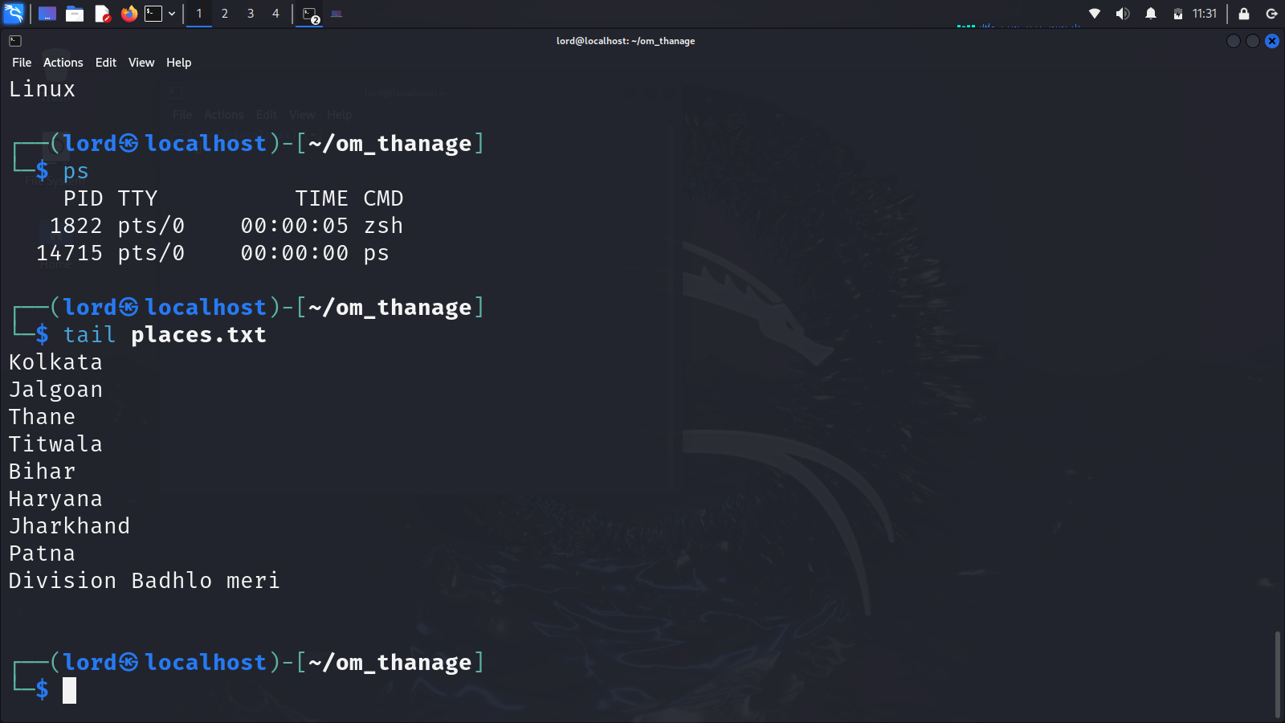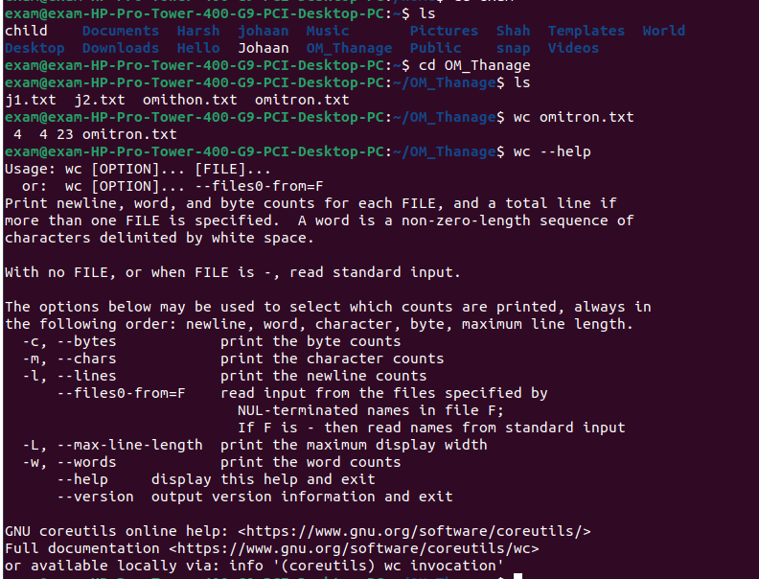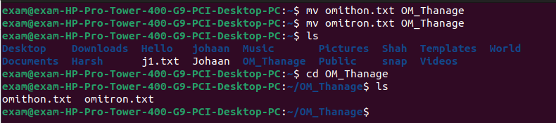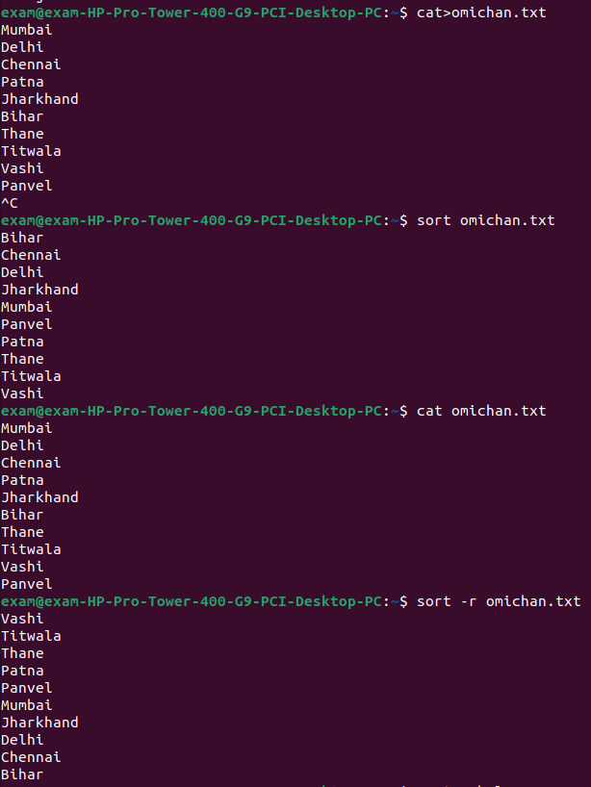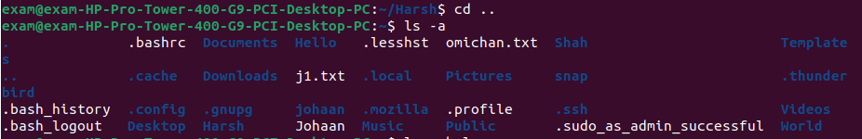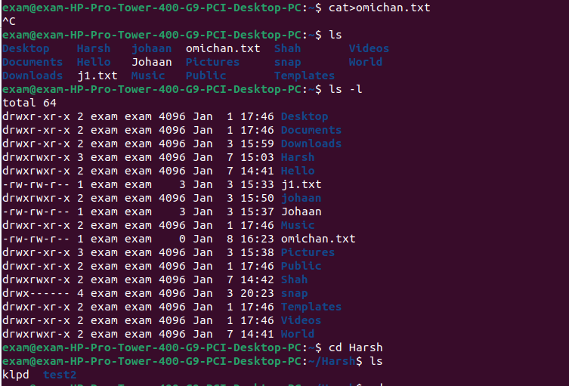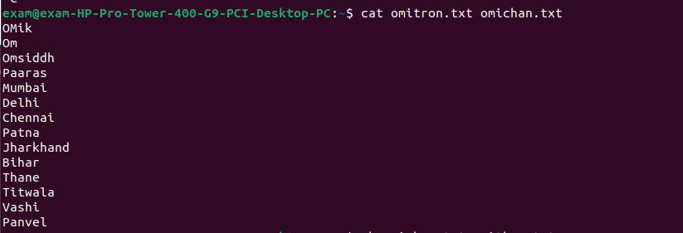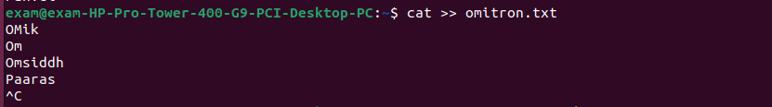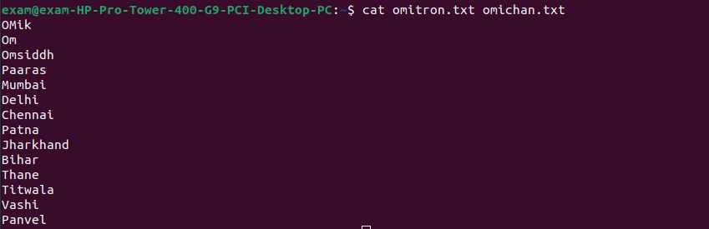
Conclusion:
In this experiment, we explored fundamental UNIX commands for managing files, directories, processes, and permissions. The practical implementation of commands such as chmod, chown, and diff enhanced our understanding of UNIX/Linux operating systems. This hands-on experience helped solidify concepts related to shell operations and system utilities, fostering a deeper appreciation for the efficiency and versatility of UNIX environments

Post Lab Multiple Choice Questions
- What does the -r option do when used with the rm command?
- Removes files recursively
- Removes files forcefully
- Removes files interactively
- Removes files silently
Answer: a
- Which command is used to move a file from one location to another?
  - cp
  - mv
  - rm
  - touch
Answer: b
- What is the purpose of the -n option in the cat command?
  - Displays the file contents in reverse order
  - Displays the file contents with line numbers
  - Displays the file contents in uppercase
  - Displays the file contents in lowercase
Answer: b
- Which command is used to search for a specific pattern in a file?
  - find
  - grep
  - locate
  - chmod
Answer: b

Post Lab Descriptive Questions

- Explain how do you read and interpret syntax of any OS command.
Ans.
1. Identify:
- Command: Core action (e.g., ls, cp).
- Options: Modifiers (e.g., -l, --verbose).
- Arguments: Data it acts on (files, values).
2. Consult:
- Tab Completion: Helps find options and their spelling.
3. Experiment:
- Try simple commands first.
- Observe output.
- Use -h or --help (if available).
In essence, break down the command, understand its parts, and use resources like the manual and tab completion to learn its syntax.
- Explain different functions of the operating systems.
Ans.
The operating system (OS) is the core software that manages a computer's resources and provides a user-friendly interface. Key functions include:
- Resource Management: Controls memory, CPU, devices, and files.
- User Interface: Provides CLI and GUI for interaction.
- Security: Enforces user authentication, access control, and protection.
- Networking: Enables communication between computers.
Essentially, the OS acts as the intermediary between the user and the hardware, ensuring efficient and secure operation.
- What are the default permissions assigned by Unix for Directory.
Ans. In Unix systems, the default permissions for a newly created directory are typically:
- rwxrwxr-x
This translates to:
- rwx: Owner has Read, Write, and Execute permissions.
- rwx: Group members have Read, Write, and Execute permissions.
- r-x: Others have Read and Execute permissions.

Date: 19/01/25 Signature of faculty in-charge

